## RDS Team Dynamics *Bi-Weekly Update*

**Assignment Goals / Deliverables:** Continuing the theme set with our first Team Dynamics assignment, we want you to get together with your team for a social activity either in-person or virtually (whichever you feel comfortable with). You can share a meal together, play a game, or something along those lines. This gathering should help you unwind a little, and allow you to reflect upon how your team has been performing over the last two weeks. As deliverables, we ask that you complete the following two tasks and upload them to the Canvas assignment:

* Take a photo / screenshot of your group at your gathering.
* Answer the questions below as a group.

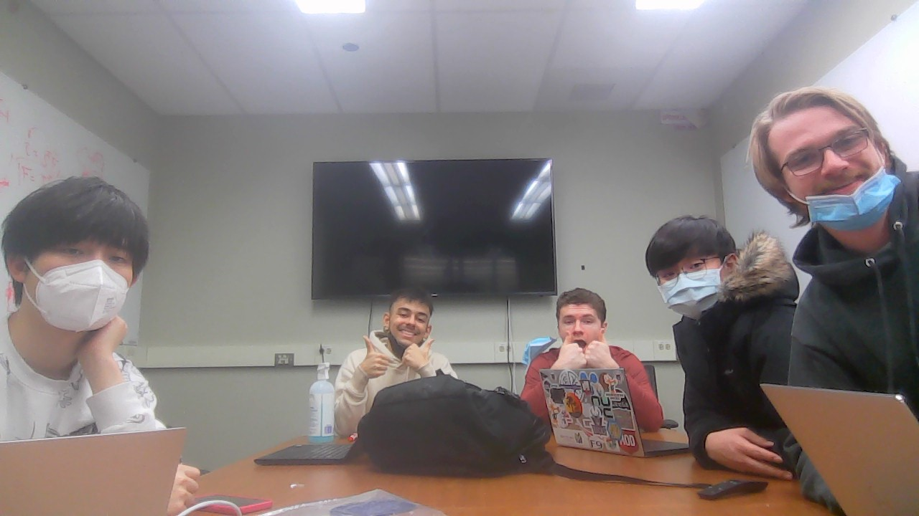

***Please be open and honest with yourselves and your group. There will be no penalties for the answers you provide in these bi-weekly updates, rather they should help you find areas for potential growth and help you recognize individual and team development.***

1. Have there been any conflicts or issues that have arisen within your team over the last two weeks? If so, what were they, and how were they resolved?

| [Answer] No issues have arisen in the past 2 weeks. |
| --- |

1. Are there any conflicts or issues within your team that are still outstanding that you would like to discuss during your next weekly meeting?

| [Answer] No outstanding issues to be resolved. |
| --- |

1. Are there any areas where you feel your team is excelling?

| [Answer]We have been iterating rapidly, moving quickly after a prototype is done to decide on what was good and bad about it and how to move forward. This has allowed us to pursue multiple avenues of magnet design at once in parallel with the overall design. We have also dealt well with tight deadlines, as we had two straight meetings with professors on Mondays, giving us less time to turn around designs, however, we did a good job of managing the workload to be prepared for those meetings. |
| --- |

1. Are there any areas where you feel your team needs improvement?

| Team organization is the biggest struggle at the moment. Coming back together after the actuator/mechanism split has brought with it the challenges of having a team of 6 members. With the alpha design and documentation deadline rapidly approaching, we need to divide the work significantly in order to finish as much as possible in the least amount of time.  Thus, people are often working on issues in parallel, and team communication is at its peak importance in order to ensure everyone is working toward a common goal. |
| --- |